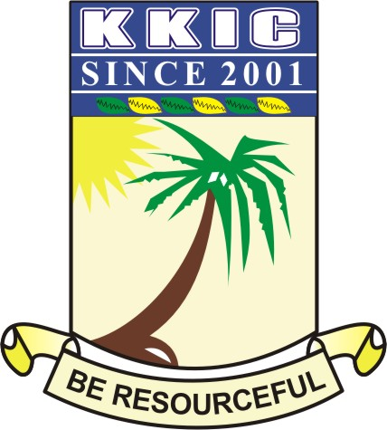

|  |  |  |  |  |  |
| --- | --- | --- | --- | --- | --- |
| **NAME** |  | | | | |
| **SUBJECT** | **HISTORY (MOCK EXAM)** | **CLASS** | **JSS 3 MOCK** | **DURATION** | **1 HR 30mins** |

**PAPER 1- OBJECTIVES**

**INSTRUCTION: ANSWER ALL QUESTIONS**

**(20 Marks)**

1. The bombardment of Lagos took place in what year?

1. 1925
2. 1856
3. 1956
4. 1851

2. Which of these was under British direct rule in Nigeria?

1. Niger Protectorate
2. Northern Protectorate
3. Lagos Crown Colony
4. Southern Protectorate

3. Mungo Park’s Niger expedition of 1795 set off from _________

1. Bambuk
2. Dakar
3. Gambia
4. Congo

4. The Berlin Conference was convened by ______

1. Otto Von Bismarck
2. Charles Taylor
3. Lord Lugard
4. William Willberforce

5. Which of the following companies was established by the Europeans to aid the Trans - Atlantic slave trade?

1. John Holt & Brother
2. Taubman Goldie Royal Company
3. Lever Brothers
4. Royal African Company

6. The European trader that eventually won Nigerian territories for Britain was __________

1. Richard Lander
2. Taubman Goldie
3. John Holt
4. Mr. Lever

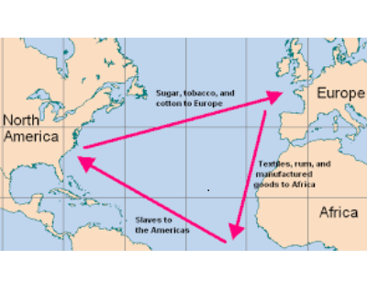

7. What does the picture above shows?

1. The Trans - Saharan Trade
2. The Afro - American Trade
3. The Triangular trade
4. The Anglo - European Trade

8. Some of the commodities that was traded in the image above were ________

A. donkeys, camels and tobacco

B. slaves, tobacco and clothes

C. sugar, slaves and tobacco

D. cars, ivory and slaves

9. One of the following is not a feature of indirect rule in Nigeria

1. it gave room for more Nigerians in the legislative council
2. it made use of traditional rulers
3. there was an executive council
4. it used modified native laws and customs

10. The __________ is the first European to get to Nigeria.

1. Portuguese
2. Greeks
3. Britons
4. Americans

11. The “New World” refers to __________

1. Britain
2. Heaven
3. America
4. New Orlean

12. Which company sponsored explorers to find the course of the Niger River?

1. Royal Niger Company
2. Association of African
3. Association of Britain for African Exploration
4. American Exploration Company

13. Who among the following persons founded the Royal Niger Company?

1. Mungo Park
2. John Holt
3. Taubman Goldie
4. Sir Fredrick Lugard

14. The Sokoto Caliphate was conquered by Lord Lugard in _______

1. 1903
2. 1904
3. 1906
4. 1809

15. Which of these 18th century philosophers did not fight against slave trade?

1. Adams Smith
2. Thomas Paine
3. Jeremy Bentham
4. Karl Max

16. The First High Commissioner of the Northern Protectorate was ______________

A. Sir Fredrick Lugard

B. Sir Walter Egerton

C. Sir Ralph Moor

D. Sir Clifford

17. Which of the following cities was a southern terminus of the trans-Saharan trade route?

A. Tripoli

B. Kanem-Borno

C. Kumbi Salem

D. Timbuktu

Use the image below to answer questions 18- 20

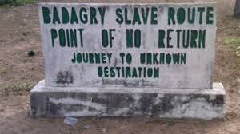

18. The Badagry slave market is a ________ source of history for the reconstruction of slave trade activities in Nigeria.

1. primary
2. secondary
3. tertiary
4. none of the Above

19. The word “Point Of No Return” means ________

1. slaves cannot return to their birth country
2. slave merchants cannot return to Africa
3. the mid men’s business has just began
4. some slaves can be free

20. Badagry can be found in _________ state in Nigeria

A. Ogun

B. Lagos

C. Oyo

D. Osun

21. An outstanding reason for the abolition of the trans-Atlantic slave trade was

A. industrial revolution

B. nationalist agitation

C. legitimate trade

D. construction of railway

22. Slave trade was officially abolished on _______

1. 25 march, 1807
2. 25 April 1907
3. 18 March, 1807
4. 27 November 1807

23. The greatest contribution of the Christian Missionary Society in West Africa was in _________

A. establishing trading companies

B. stopping the slave trade

C. the emergence of educated elite

D. the production of cash crop

24. Which of these people fought against slave trade in the British parliament?

1. Mungo Park
2. Lord Lugard
3. William Wilberforce
4. Marry Slessor

25. The anti- slave trade patrol of West African coast by the British started in _____________

A. 1815, by British Royal Navy

B. 1915, by Royal Niger Company

C. 1809, by British Royal Company

D. 1805, by Royal Niger Company

26. It was difficult for the Nigerian coastal chiefs to give up the slave trade after its abolition because

A. it had been part of African culture

B**.** Africans were too involved to give up the trade

C**.** the British Navy was not effective in enforcing the abolition

D**.** the trade was still crucial to the economy of their states.

27. ___________ was an African slave that eventually became a missionary in Nigeria

1. Mungo Park
2. Arch Bishop Idahosa
3. Mary Slessor
4. Samuel Crowther

28. The First High Commissioner of Colony and Protectorate of Southern Nigeria was _________

1. Sir Fredrick Lugard
2. Sir Ralph Moor
3. Sir Taubman Goldie
4. Sir Walter Egerton

29. The Yoruba newspaper, “Iwe Irohin” was established in ________

A. 1853

B. 1859

C. 1854

D. 1857

30. The British war against the Ijebu kingdom was fought in ____________

1. 1892
2. 1909
3. 1888
4. 1926

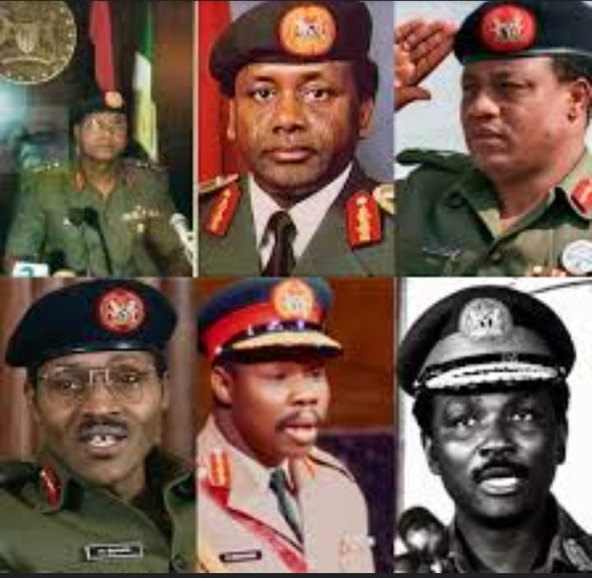

Use the image above to answer questions 31 – 33

31. When was the first coup D’etat in Nigeria?

1. 16th January, 1966
2. 17th January, 1966
3. 15th January, 1966
4. 26th January, 1966

32. The term “coup D’etat” means _______

1. sudden civilians takeover of government
2. civilians takeover of government
3. civilians takeover of government by force
4. sudden military takeover of government by force

33. The military past leaders as shown in the image above are called __________

A. president

B. head of state

C. chairmen

D. senators

34. Which of these Kings was deposed as a result of British Bombardment of Lagos?

A. Oba of Benin

1. Oba Dosunmu
2. Oba Akitoye
3. Oba Kosoko

35. The 1861 Lagos treaty of cession was signed by

_________________

1. Oba Akitoye
2. Oba Adesola
3. Oba Dosunmu
4. Oba Adele

36. The Colony and Protectorate of Southern Nigeria came into existence in _____________

1. 1906
2. 1820
3. 1914
4. 1915

37. Which of the following was the premier of the Eastern Nigeria during the first Republic?

A. Dennise Osadebay

B. Chief. Obafemi Awolowo

C. Sir. Ahmadu Bello

D. Michael Okpara

38. The first motion for Nigerian independence was moved by __________

A. Abubakar Tafawa Balewa

B. Aminu Kano

C. Anthony Enahoro

D. Herbert Macaulay

39. The Niger Coast Protectorate was formed in __________

1. 1893
2. 1914
3. 1908
4. 1820

40. The second treaty of protection signed by the British with the Itsekiri was in __________

1. 1894
2. 1896
3. 1889
4. 1800

41. The first mission station in Nigeria was situated in _________

1. Abeokuta
2. Badagry
3. Epe
4. Ibadan

42. Nigeria came into existence in ___________

1. 1914
2. 1814
3. 1950
4. 1861

43. Lagos became a Crown colony in __________

1. 1861
2. 1840
3. 1855
4. 1914

44. The two tribes that primarily engaged in the Trans - Saharan trade were ________ and __________

1. Hausa and Ijo
2. Berbers and Tuaregs
3. Koi Koi and Bantu
4. Axumites and Nwene Mutapa

45. ____________ is the father of objective history

1. Aristotle
2. Xerxes
3. Herodotus
4. Moses

46. The history of many Nigerian tribes has more than one account because

1. they are seeking political advantage
2. they cannot remember their true history
3. lack of early writing culture
4. all of the above

47. Traditions of origin are ___________

1. practices and customs in a particular society
2. beliefs in the existence of a supreme being
3. accounts about the origin of a tribe
4. original culture of a people

48. Mungo Park is a European explorer from _____

1. Britain
2. Russia
3. Scotland
4. Portugal

49. The negative impact of the Atlantic slave on Nigeria was the _________

A. de-population of the workforce

B. exchange of ideas

C. exploitation of labour force

D. importation of foreign goods

50. The indirect rule was first introduced to _______ part of Nigeria.

A. southern

B. northern

C. eastern

D. western

**SECTION B: THEORY**

**INSTRUCTION: ANSWER QUESTION 1 AND OTHER THREE QUESTIONS OF CHOICE**

(1) The amalgamation of the Northern and Southern protectorate of 1914 by Sir. Lord Fredrick Lugard was done for the benefits of the British colonialist or for the betterment of the Nigerians. Discuss with 4 vital points. **(8 marks)**

(b) Explain the term Democracy Day **(2 mark)**

(2) Who was considered to be the founding father of Nigerian nationalism? **(2 mark)**

(b) Explain the term amalgamation. **(2 marks)**

(c) Mention 3 demerits of Richard constitution of 1946. **(6 marks)**

(3) The first Republic of Nigeria was ruled by different leaders representing their regions as premiers. Mention them, with their regions and their years. **(5 marks)**

(b) List 3 features of direct rule in Nigeria.

**(3 marks)**

(c) Mention 2 different types of nationalist movements. **(2 mark)**

(4) Explain the term Coup D’etat. **(2 marks)**

(b) Mention three merits of Hugh Clifford’s constitution of 1922. **(3 marks)**

(c) List five aftermath of the first coup D’etat of 1966. **(5 marks)**

(5) Mention 4 constitutional developments in Nigeria with their dates. **(4 marks)**

(b) Write 3 causes of amalgamation. **(3 marks)**

(c) Discuss the British colonial economy in Nigeria.

**(3 marks)**

(6) Write 4 merits of Sir Arthur Richard’s constitution of 1946. **(4 marks)**

(b) During the 1966 Nigerian counter-coup. Mention any 2 principal coup plotters with their portfolios.

**(2 marks)**

(c) Mention two achievements of Sir Tafawa Balewa.

**(4 marks)**